The aboveground box takes five atmospheric inputs: temperature, precipitation, VPD, cloudiness (as a proxy for light), and tidal water level. These drive photosynthesis (GPP), and the box loses carbon through respiration, litterfall, herbivory, and tidal export. Precipitation also acts on the belowground box indirectly, because it reduces salinity.
The belowground box takes salinity, flooding, and nutrients, and loses carbon through root respiration, decomposition, and burial as peat. Allocation carries carbon down from the aboveground box, and remobilization sends some back up. The aboveground box might look like this:
dA/dt = GPP (T, P, VPD, Cl, water) − Rₐ − litterfall − herbivory − export − allocation + remobilization
FPAR here is the fraction of photosynthetically active radiation, which you would estimate from vegetation index. The belowground box would be:
dB/dt = allocation − remobilization + root growth – Root respiration− decomposition − burial
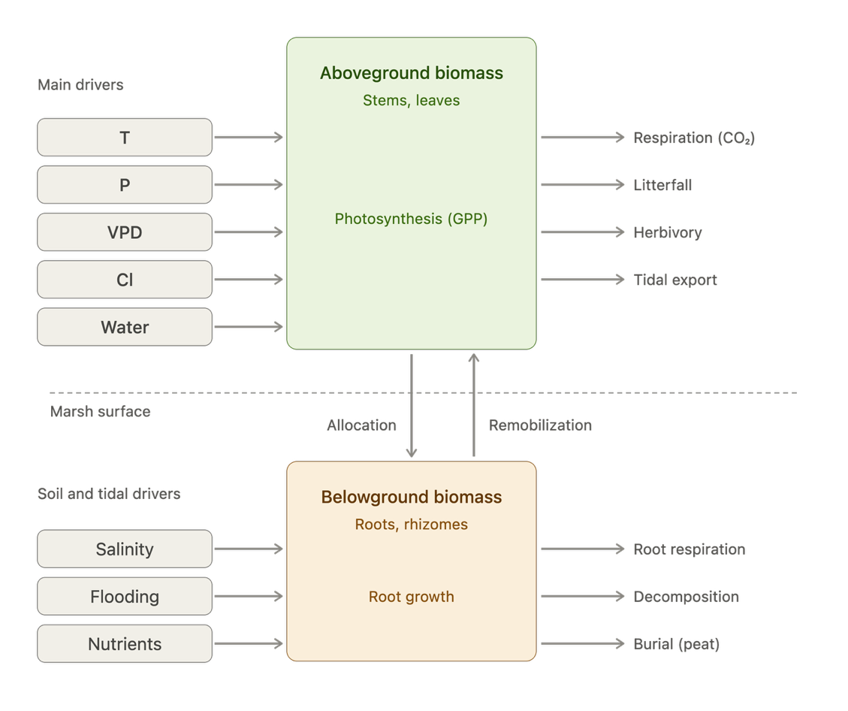
I feel like this is a very basic example of the box model for above(below) ground biomass productivity modeling.

